WHAT IS NEEDED TO PLAY
Knowledge Check - Questions

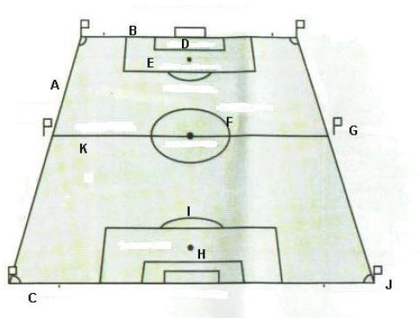
For questions 1-5, choose from the following letters in the diagram below: A, B, C, D, E, F, G, H, I, J, K
- Center Circle

- Penalty Area

- Goal Line

- Touchline

- Goal Area

- A goalkeeper may make a mark on the field with his/her cleats so that they can tell where the mark for the edge of the penalty area is outside the normal field markings.
True False

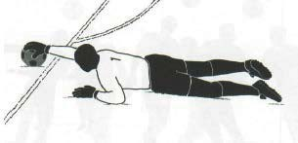
- In the picture (at right) the goalkeeper is outside the penalty area but has reached into the area to control the ball. What is your call?
Direct Free Kick Indirect Free Kick No Offense

- Use the field (at right) to decide the distance (in yards) for each measurement. Choose from the following: 1 yard, 6 yards, 8 yards, 10 yards, 12 yards, 18 yards
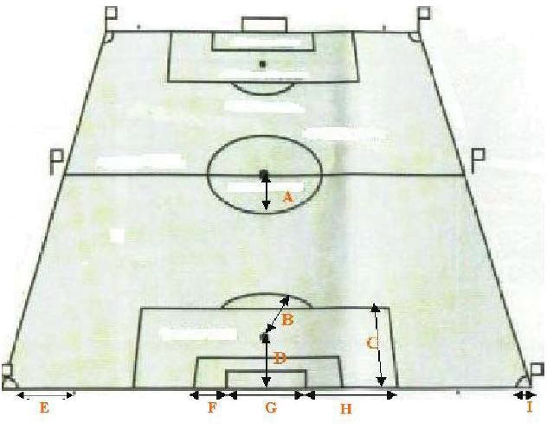

- Players of all ages MUST use the same size ball. True False

- The proper restart when a ball burts or becomes defective during the course of play is an indirect free kick for the team in possession at the time the ball became defective.
True False

- The ball may not be changed during the match without the authority of the referee. True False

- Who is responsible for checking the ball or balls for the match prior to beginning of the match?
A. Referee
B. Assistant Referee
C. Team Captains
D. Fourth Official
E. Both A & B
F. Both A & D

- When inspecting the ball, what are some of the critical features to be assessed?
A. Is it round?
B. Is it the right size for the match?
C. Is it made of suitable material?
D. Is it properly inflated?
E. All of the above
F. None of the above

A Seniors match is played by two teams, each consisting of not more than eleven players, one of whom is a goalkeeper. A match may not start if either team consists of fewer than seven players.
True False

- A substitute becomes a player when…
A. a formal request for substitution is made.
B. the referee signals the substitute to enter the field.
C. the other referee blows the whistle.
D. he enters the field of play.
E. Both B & D
F. Both A, B & D

- Any player may take the place of the goalkeeper as long as the referee is informed and it is done at a stoppage of play.
True False

If a goal is scored by the team that had more than the allowed number of players and the referee discovers this before play is restarted, the goal remains valid and may not be taken away.
True False

- Which of the following is NOT a way to avoid allowing the substitution process to delay the game? (there may be more than one right answer)
A. Do not allow any substitution when there is less than one minute remaining in the game.
B. Add time.
C. Do not allow a substitution if the substitute is not prepared to enter the game and inform the coach that substitution can be made at the next opportunity.
D. If the delays persist and are clearly designed to delay the game, issue a caution to the coach for unsporting behavior.

- If a player accidentially passes over one of the boundary lines of the field of play or if a player in possession of or contesting for the ball passes over the touch line or the goal line without the ball to beat an opponent, the referee must:
A. give the player permission to re-enter the field of play.
B. caution the player and show the yellow card.
C. do nothing, as no foul or misconduct has occurred.
D. restart play with an indirect free kick for the opposing team at the point where the player illegally re-entered the field of play.

- The referee may caution or eject and show the appropriate card to a substitute for misconduct. True False

- Misconduct committed prior to the start of a match by a player or substitute is subject to a formal caution or ejection, the referee should show the appropriate card but inform both teams and any match officials of the event.
True False

- A player must not wear anything that is dangerous to himself or other players. True False

- Which of the following is NOT part of basic compulsory equipment for players?
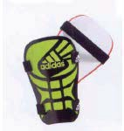
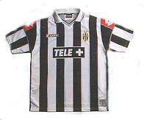
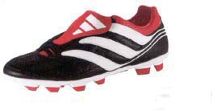
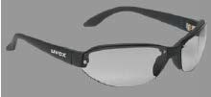
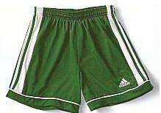
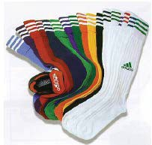

- Shin-guards must be covered completely by socks. True False

- Each goalkeeper must wear colors which distinguish them from:
A. their teammates
B. their opponents
C. the other goalkeeper
D. the referees
E. all of the above
F. Both A & C

- Shin-guards must be of a specific size. True False

- Which of the following are steps in dealing with infringements of Law IV?
A. Play must be stopped
B. Player is instructed to leave the field of play and repair equipment
C. Any player who has left the field of play to correct equipment may re-enter at any time
D. The referee must first check that the equipment has been properly corrected before the player may re-enter
E. All of the above
F. Both A & C

- Player's jerseys must be tucked in at all times. True False

- Which of the following are exceptions to the no jewelry stipulation?
A. Trainer earrings that can not be removed at risk of closure of the hole in the earlobe.
B. Medical or religious jewelry that has been secured.
C. Friendship bracelets.
D. All of the above
E. Both A & C
F. None of the above.

- Goalkeepers can wear any extra equipment that they want. True False

