THINGS PLAYERS DO
Knowledge Check - Questions

- If a player is in an offside position, they are guilty of the offense of offside. True False

- To be in an offside position, the player must be nearer the goal line than the second-to-last defender or the ball.
True False

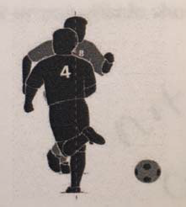
- Player #4 (pictued at right) is level with the defender. True False

- Which of the following is NOT a direct free kick foul or misconduct offense:
  - Striking or attempting to strike
  - Charging an opponent
  - Impeding the progress of an opponent
  - Spitting at an opponent

- Which of the following is NOT an indirect free kick four or misconduct offense:
  - Playing in a dangerous manner
  - Jumping at an opponent
  - Preventing the goalkeeper from releasing the ball from his hands
  - Goalkeeper taking more than six seconds before releasing the ball from his possession

- If the restart following a foul is a direct free kick or penalty kick, a penal foul has occurred. True False

- Which of the following are not a criteria for an obvious goal‐scoring opportunity?
A. The direction of play (the player must be running toward the opponents' goal, not toward the goal line or the corner).
B. The foul occurs within the opponent's penalty area.
C. The proximity of the ball (could the player have reached it to play it?).
D. The location and number of opponents albe to participate immediately (one or none between the player and the goal, in addition to the opponent infringing Law XII).

- Referees are being unprofessional if they attempt to inject humor into a tense situation.
True False

- Which of the following pictures represent potential direct free kick fouls or misconduct?
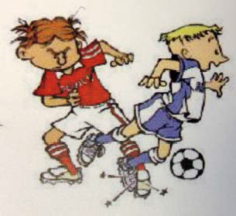
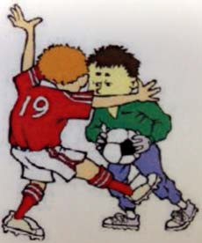

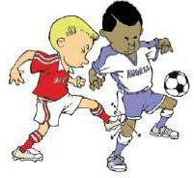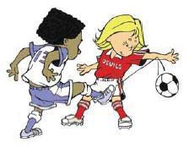

- Opponents may not use their bodies to attempt to gain an advantage, keep possession of the ball and create time and space.
True False

- As little as a single finger is sufficient for goalkeeper possession of the ball.
True False

- If you deem the foul reckelss, award the direct free kick plus a caution. True False

- The proper required distance for a free kick is:

Passers (U8) | 6 yards | 8 yards | 10 yards | 10 feet
Wings (U10) | 6 yards | 8 yards | 10 yards | 10 feet
Strikers (U12) ‐ | Seniors (U19) | 6 yards | 8 yards | 10 yards | 10 feet

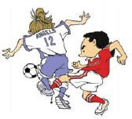
- The picture (at right) is an example of pushing:
True False

- Choose the picture that is NOT an example of a tripping infraction.
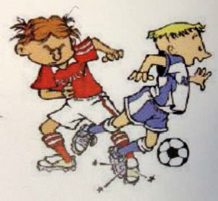
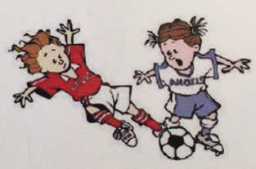

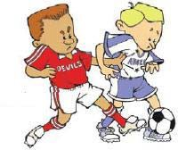

- If a player tackles an opponent to gain possession of the ball but makes contact with the opponent before touching the ball, award a direct free kick.
True False

- Referees have the authority to make the players leave the field or the vicinity of the penalty area when a penalty kick is being taken in extended time.
True False

- A defender strikes an attacker in the penalty area while the ball is in play at the midfield. The proper restart is:
A. an indirect free kick for the attacking team at the point of the foul
B. a direct free kick for the attacking team at the point where the ball was when the foul occurred.
C. a penalty kick for the attacking team
D. a dropped ball at the point where the ball was when the foul occurred.

- Which of the following is NOT a required step for the performance of a penalty kick:
A. the players not involved in the penalty kick are outside the penalty area.
B. the kicker is identified
C. the ball is placed on the mark
D. the goalkeepr and the kicker shake hands prior to the kick

- The proper mechanic for signaling a penalty kick to run to the penalty mark and stand there until the players have established their positions.
True False

- Which is the proper signal for a penalty kick?
